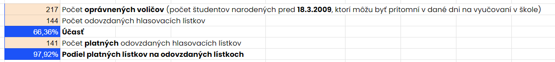

Poradie | Meno kandidáta | Počet hlasov | Podiel
1. | Ivan Korčok | 109 | 77,30%
2. | Peter Pellegrini | 15 | 10,64%
3. | Marian Kotleba | 7 | 4,96%
4. | Igor Matovič | 3 | 2,13%
5. | Krisztián Forró | 2 | 1,42%
6. | Štefan Harabin | 2 | 1,42%
7. | Ján Kubiš | 2 | 1,42%
8. | Patrik Dubovský | 1 | 0,71%

