- How many kinds of athomes are exist?
- 95 b) 46 c) 80 d) 92
- Who has discovered the periodic law?
- Aristotheles b) Mendel c) Laurent de Lavoisier d) Mendelejev
- An element is a substance made of only one kind of atom.
- Its true or b) false
- How meny elements are there in modern periodic table?
- 100 b)92 c)114 d) 118
- In how many vertical columns are aranged the periodic table?
- 7 b) 10 c)20 d) 15 e) 18
- How we called the columns in PTE?
- Road b)groups c) rows d) lines
- How we called the horizontal line of element?
- Line b) order c) que d)row
- Alkali metals are elements of II. Period.
- True b) false
- How we called the elements of 18 th group?
- Alcali non-metals, b) chalcogens c) Noble gases d) halogens
- How we called the elements of 17 group?
- Alcali metals b) halogens c) Noble gases d) metals
- Choose corect answer of periodic table:
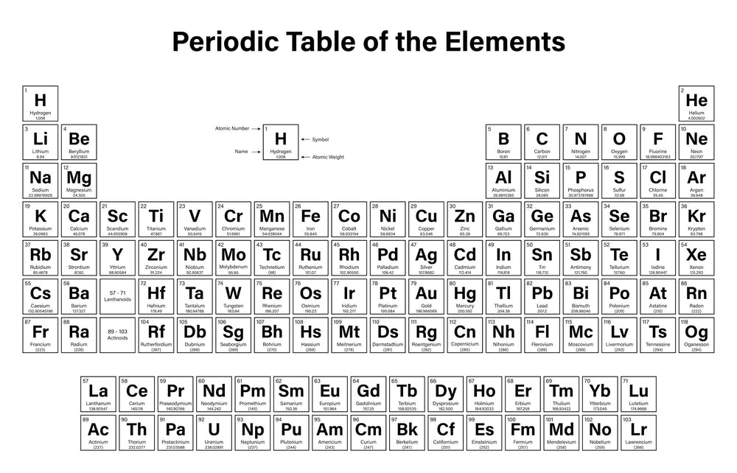
- What is the name of atomic number 30 ?
............................................................
- What is the name of atomic number 3?
............................................................
- What is the atomic number of calcium?
...................
- Whitch row is sulfur in?
.......................................
- Choose one of the elements of third row.
......................................
- Whitch properties are belong to metals?
a)shiny b) elektric conductor c) malleable d) magnetic
g) sulfur and selenium don´t conect the electricity.
True and false
- Opposite propertiy of malleable is
1)Aironic 2) liqued 3) brittle 4) shiny 5) magnetic

- Non-metals are situated on left side of diagonal of semi metals.
True or false
- Metals are situated on right hand side of diagonal of semi metals.
True or false

