Pobyt w Parku Trampolin z okazji Dnia Dziecka

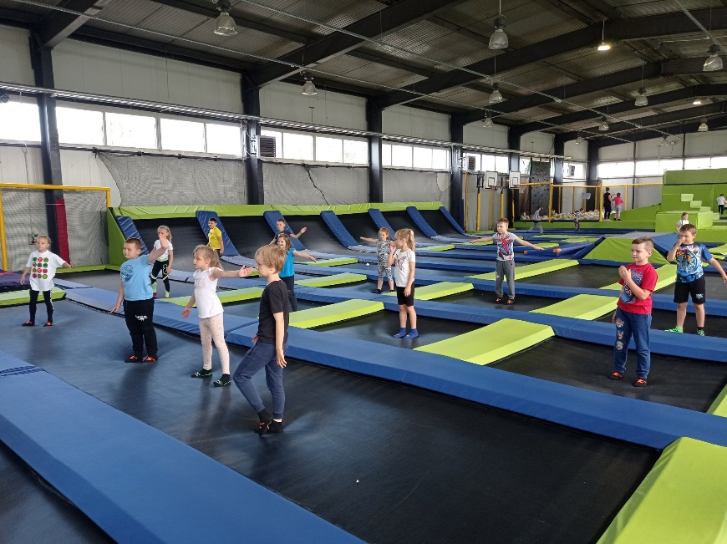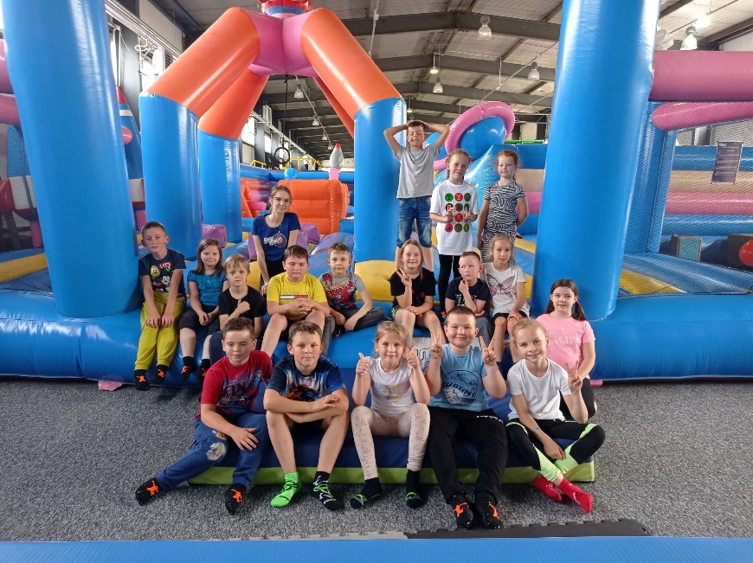

https://www.facebook.com/Szko%C5%82a-Podstawowa-Borowa-103319884856629/photos/pcb.525867722601841/525867669268513/

Gromada Zuchowa ,,Leśne Duszki” sadzi wiśnie w OREW Wola Pławska

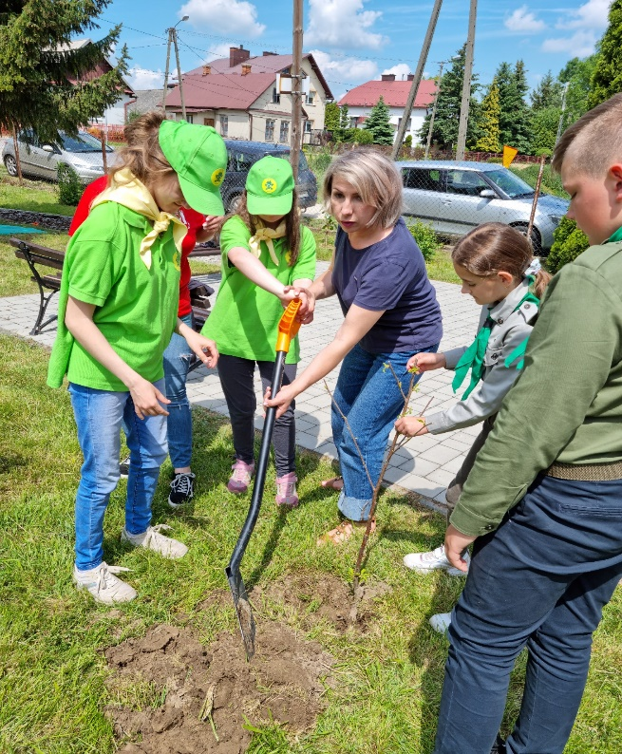

https://spborowa.edupage.org/news/?eqa=d2lkPW5ld3NfTmV3c18xX3AmbmV3c2FyY2hpdmVmPSZvZmZzZXRfbmV3c19OZXdzXzFfcD0yMA%3D%3D#

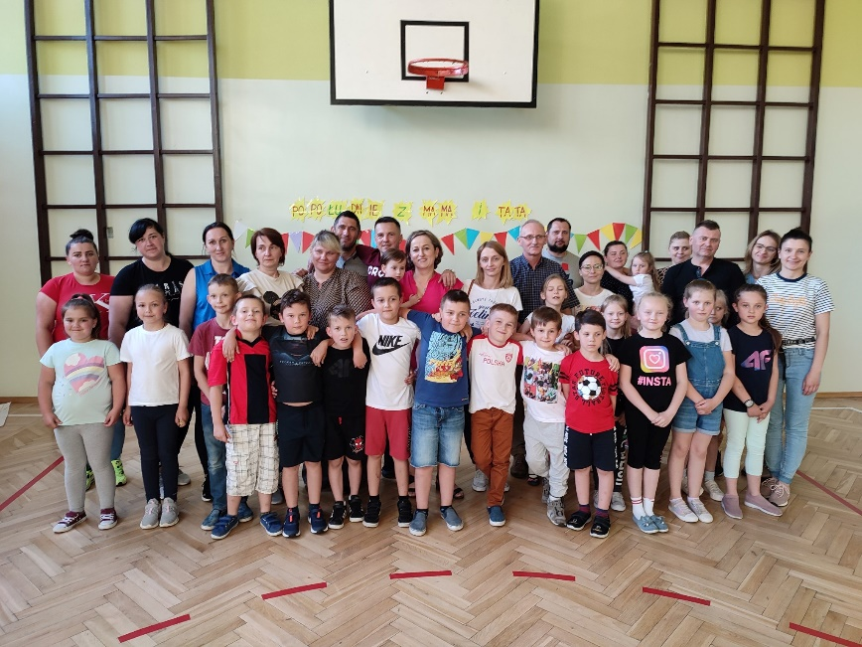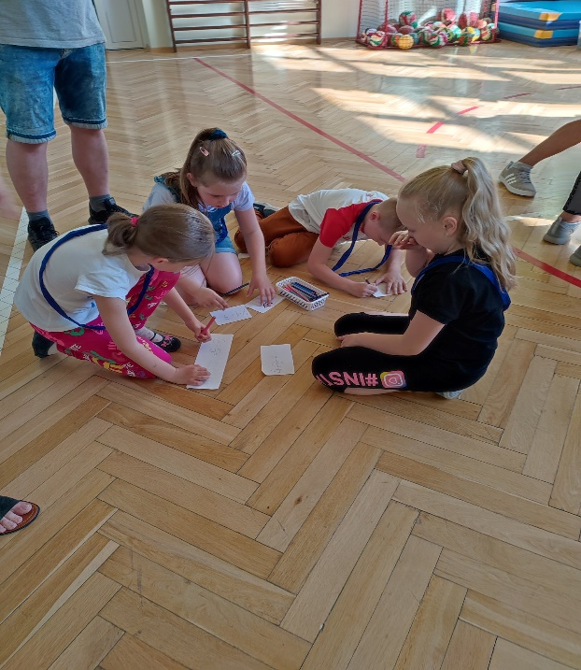
https://spborowa.edupage.org/news/?eqa=d2lkPW5ld3NfTmV3c18xX3AmbmV3c2FyY2hpdmVmPSZvZmZzZXRfbmV3c19OZXdzXzFfcD0yMA%3D%3D#
Popołudnie z mamą i tatą w I b

Dzień Rodziny w przedszkolu

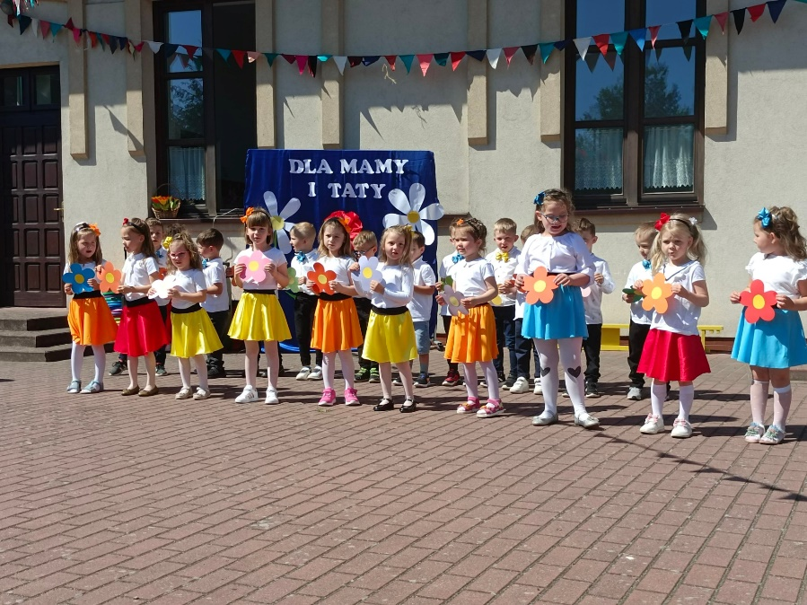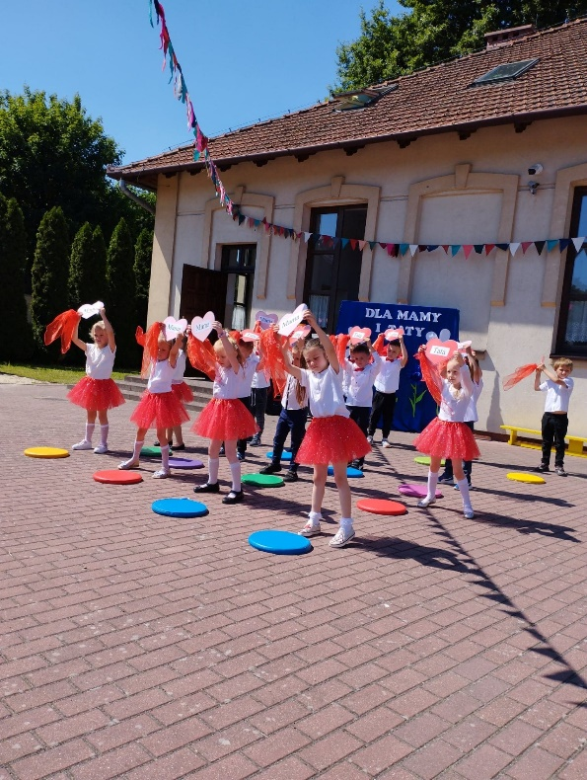
https://spborowa.edupage.org/news/?eqa=d2lkPW5ld3NfTmV3c18xX3AmbmV3c2FyY2hpdmVmPSZvZmZzZXRfbmV3c19OZXdzXzFfcD0yMA%3D%3D#

Hasztaszki szlifują formę na nowym boisku

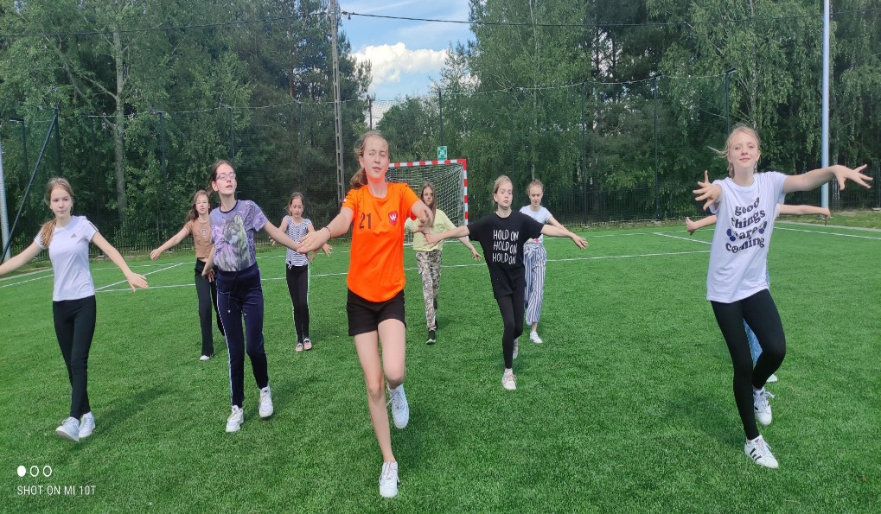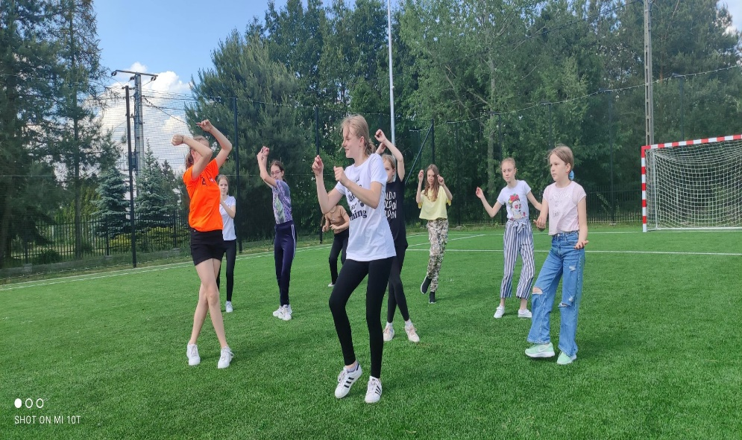

https://www.facebook.com/Szko%C5%82a-Podstawowa-Borowa-103319884856629/photos/pcb.527353942453219/527353375786609/

Spotkanie z Panią Leśniczy

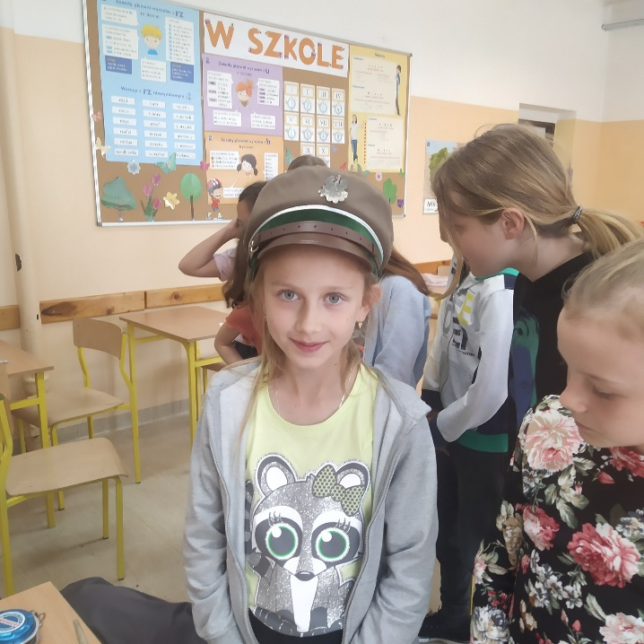

https://spborowa.edupage.org/news/?eqa=d2lkPW5ld3NfTmV3c18xX3AmbmV3c2FyY2hpdmVmPSZvZmZzZXRfbmV3c19OZXdzXzFfcD0yMA%3D%3D#

Wyjątkowe spotkanie w przedszkolu
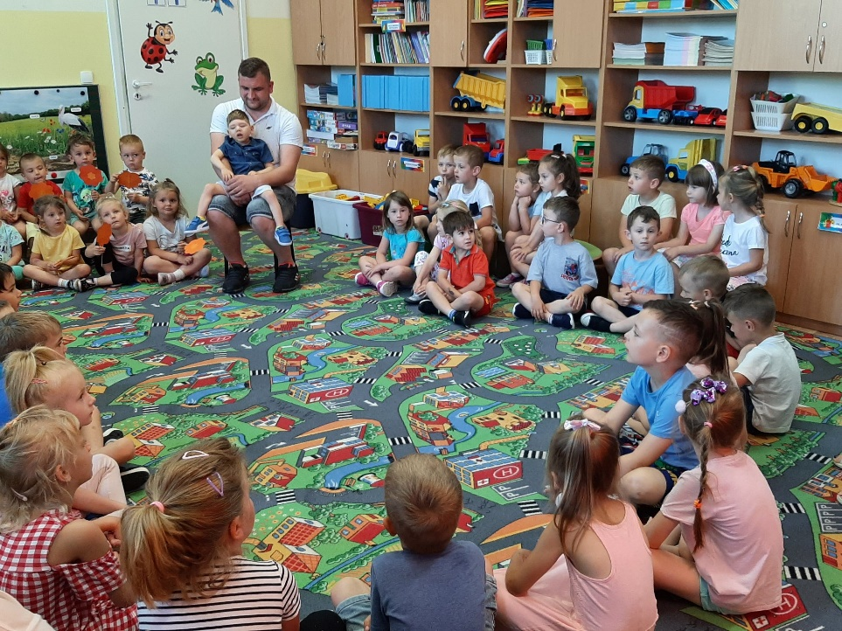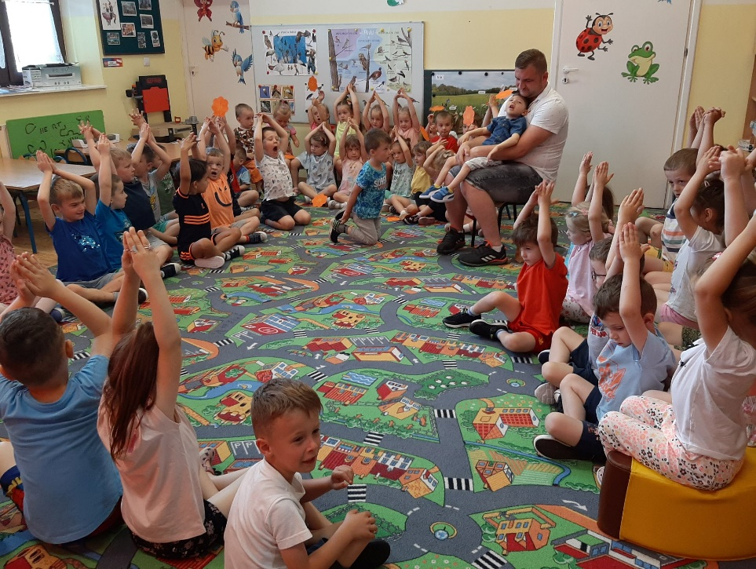

https://www.facebook.com/Szko%C5%82a-Podstawowa-Borowa-103319884856629/photos/pcb.529350415586905/529350305586916

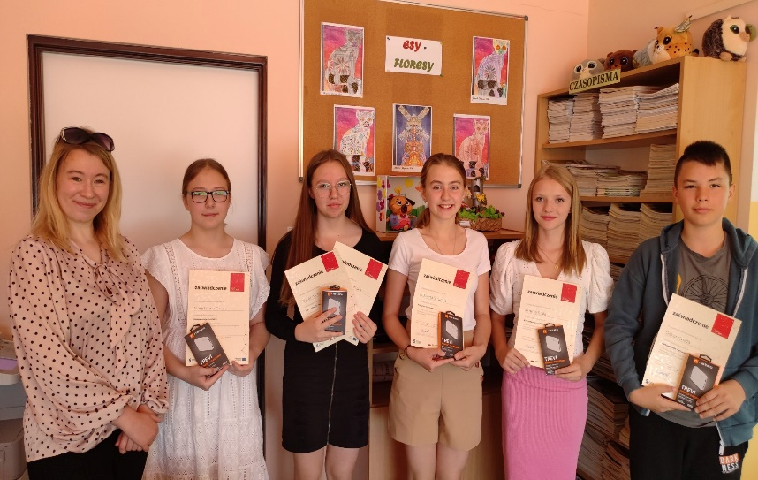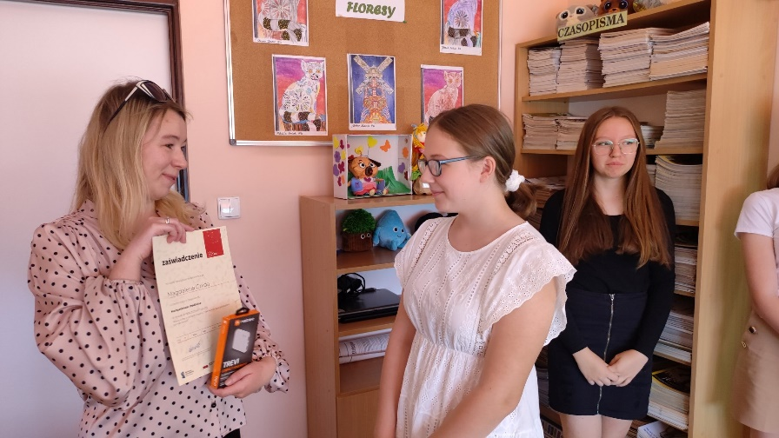
Sieć na kulturę

https://www.facebook.com/Szko%C5%82a-Podstawowa-Borowa-103319884856629/photos/pcb.529747628880517/529747502213863

Zdrowe tortille

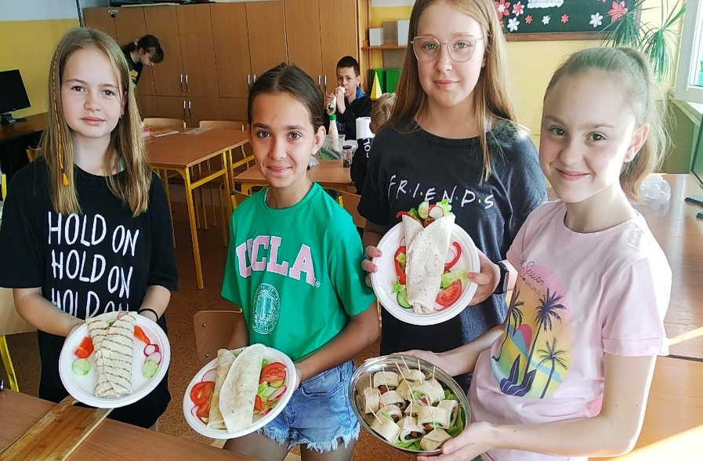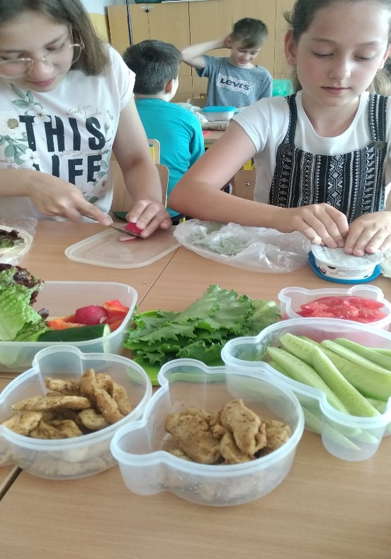

https://www.facebook.com/Szko%C5%82a-Podstawowa-Borowa-103319884856629/photos/pcb.530752692113344/530752365446710

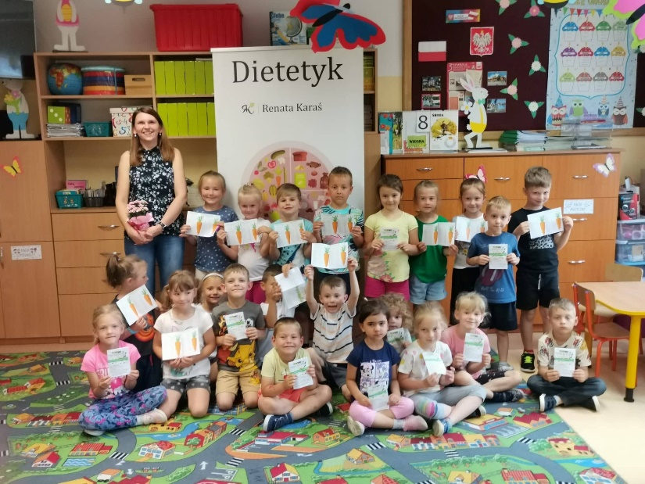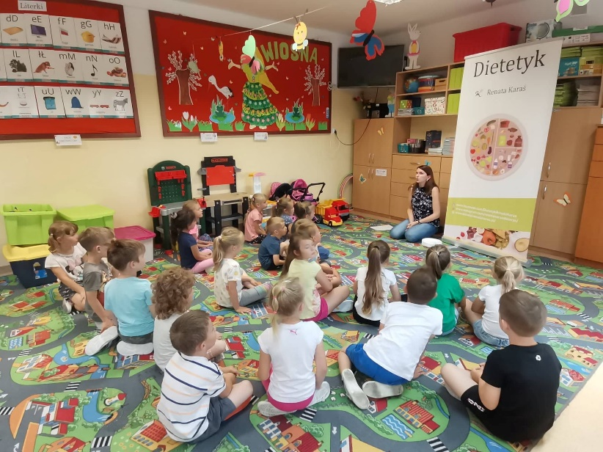
Spotkanie z Panią dietetyk

https://spborowa.edupage.org/news/?eqa=d2lkPW5ld3NfTmV3c18xX3AmbmV3c2FyY2hpdmVmPSZvZmZzZXRfbmV3c19OZXdzXzFfcD0w#

Uroczystość otwarcia boisk wielofunkcyjnych
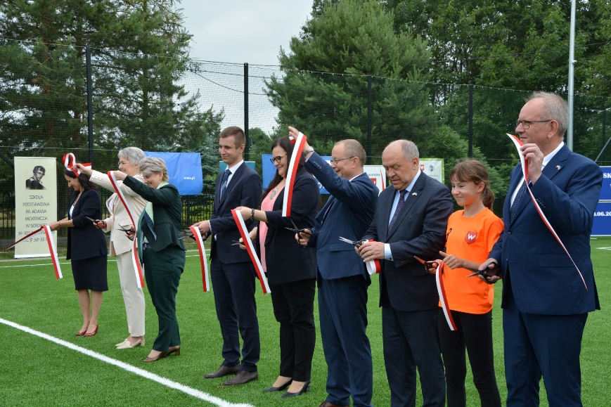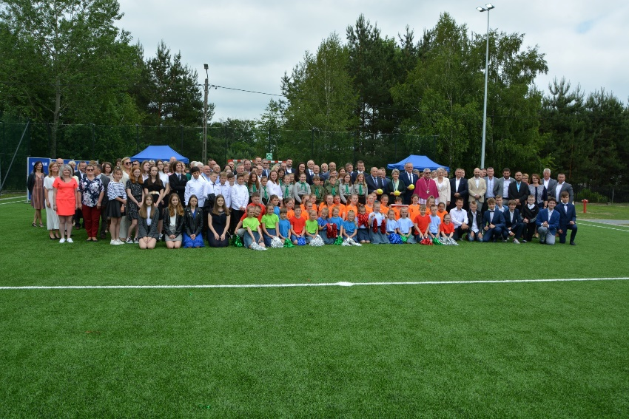

https://www.facebook.com/Szko%C5%82a-Podstawowa-Borowa-103319884856629

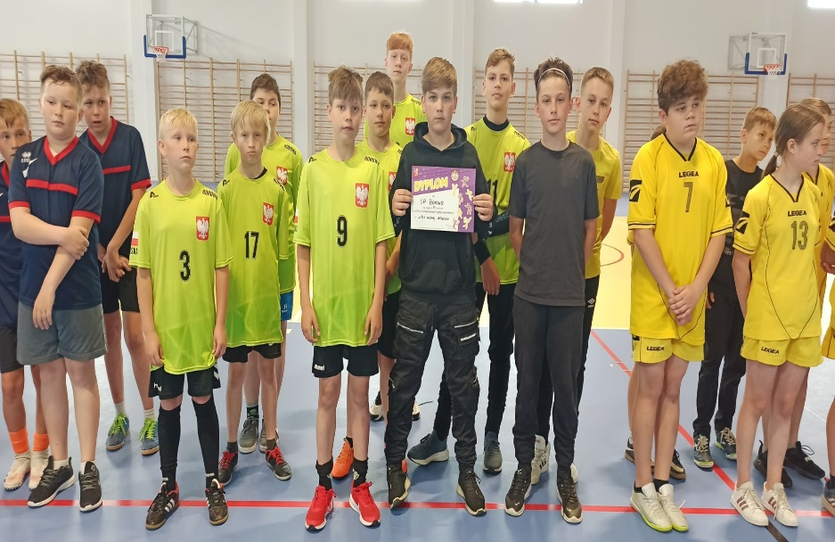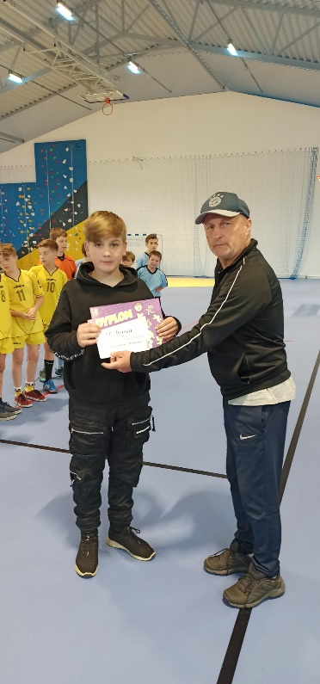
Piłkarze z klas IV- VI w Jaślanach
z III miejscem

https://spborowa.edupage.org/news/?eqa=d2lkPW5ld3NfTmV3c18xX3AmbmV3c2FyY2hpdmVmPSZvZmZzZXRfbmV3c19OZXdzXzFfcD0w#
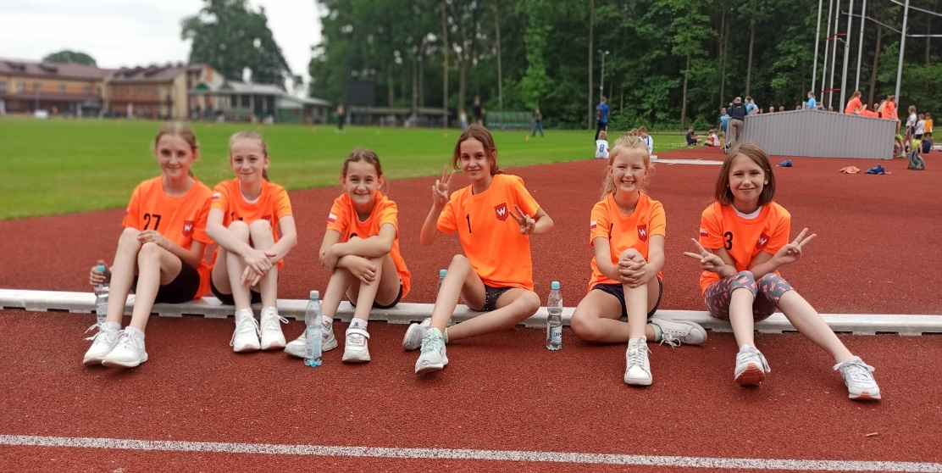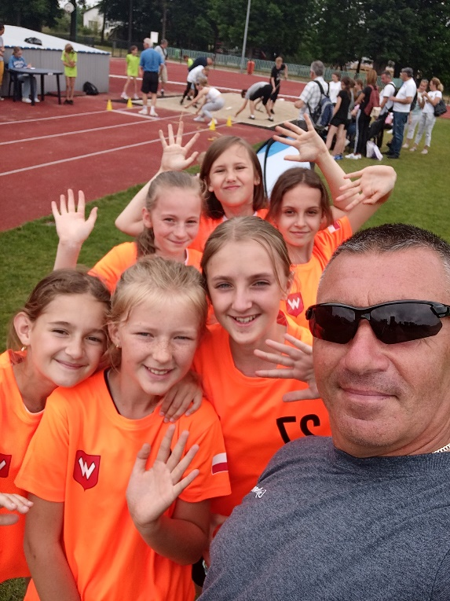
Wspaniałe trójboistki

https://spborowa.edupage.org/news/?eqa=d2lkPW5ld3NfTmV3c18xX3AmbmV3c2FyY2hpdmVmPSZvZmZzZXRfbmV3c19OZXdzXzFfcD0w#
Kangur matematyczny

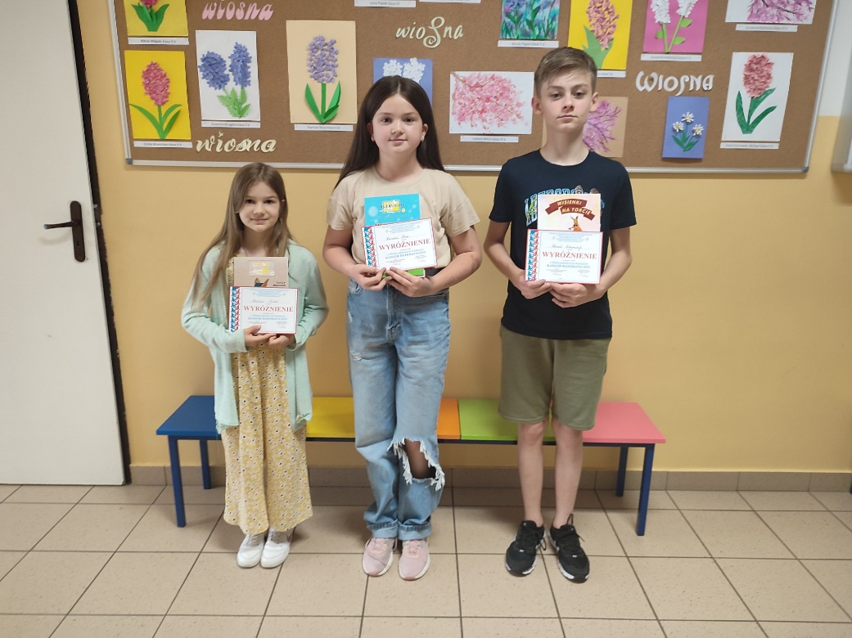
https://www.facebook.com/Szko%C5%82a-Podstawowa-Borowa-103319884856629/photos/pcb.533162198539060/533161661872447/

Przyjaciele na zawsze
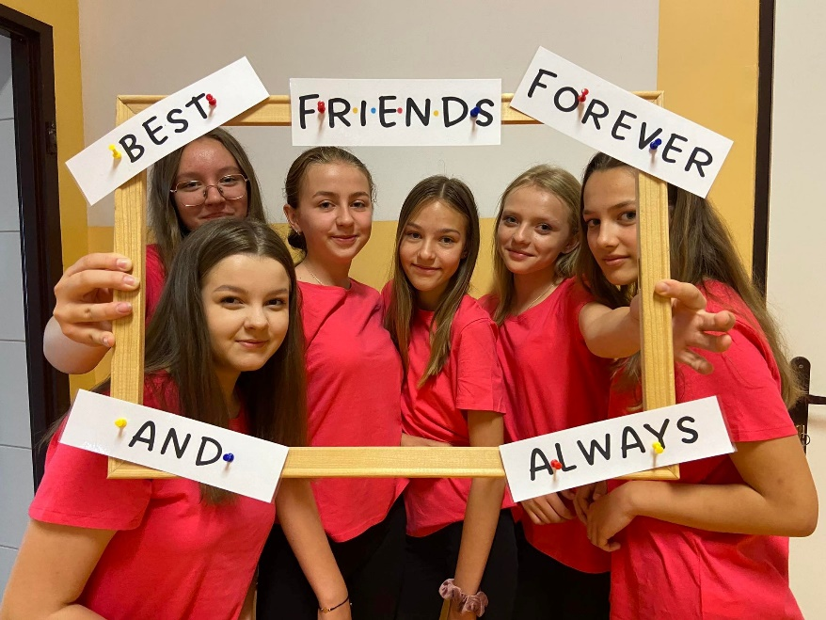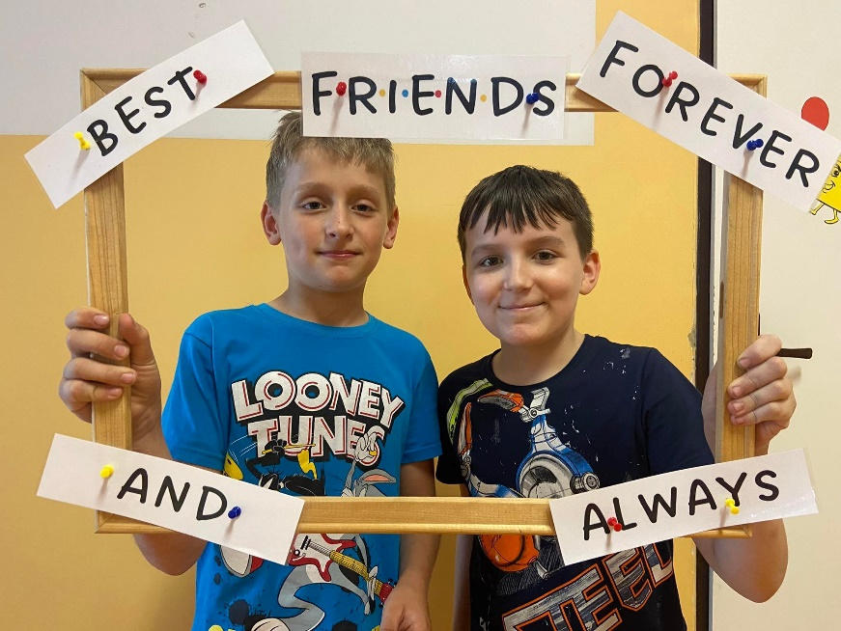

https://www.facebook.com/Szko%C5%82a-Podstawowa-Borowa-103319884856629/photos/pcb.533148565207090/533146471873966

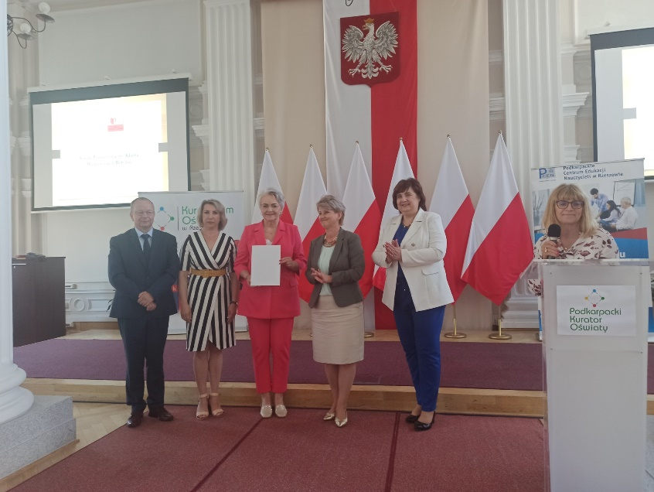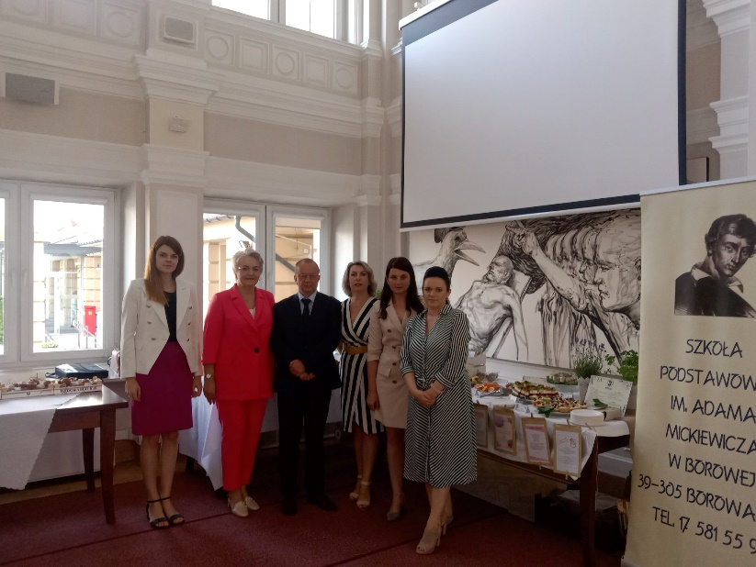
Wojewódzki Certyfikat Szkoły Promującej Zdrowie

https://spborowa.edupage.org/news/?eqa=d2lkPW5ld3NfTmV3c18xX3AmbmV3c2FyY2hpdmVmPSZvZmZzZXRfbmV3c19OZXdzXzFfcD0w#

Szkolny konkurs przyrodniczy

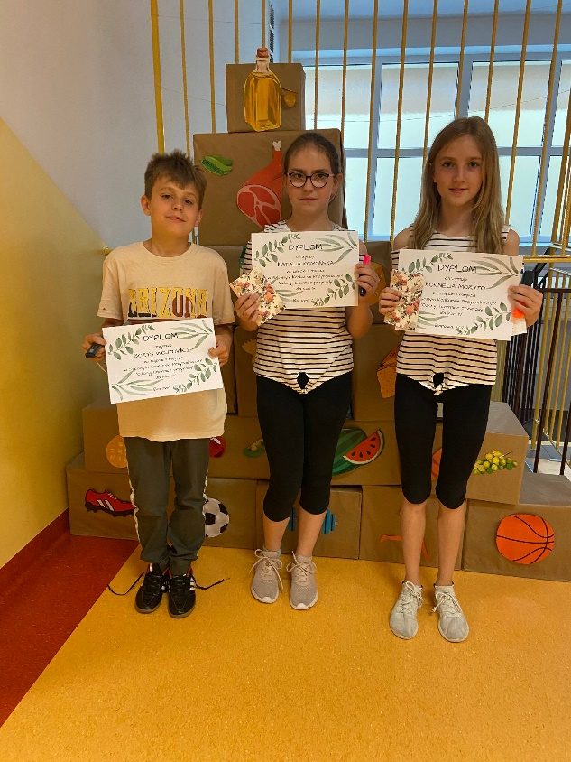
https://www.facebook.com/Szko%C5%82a-Podstawowa-Borowa-103319884856629/photos/pcb.534040051784608/534039941784619
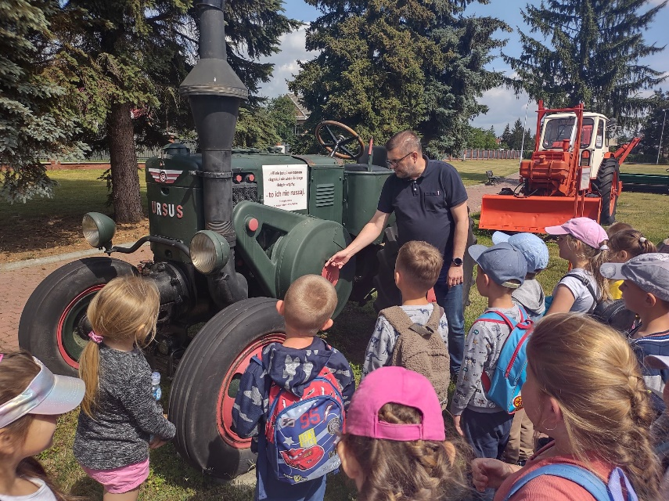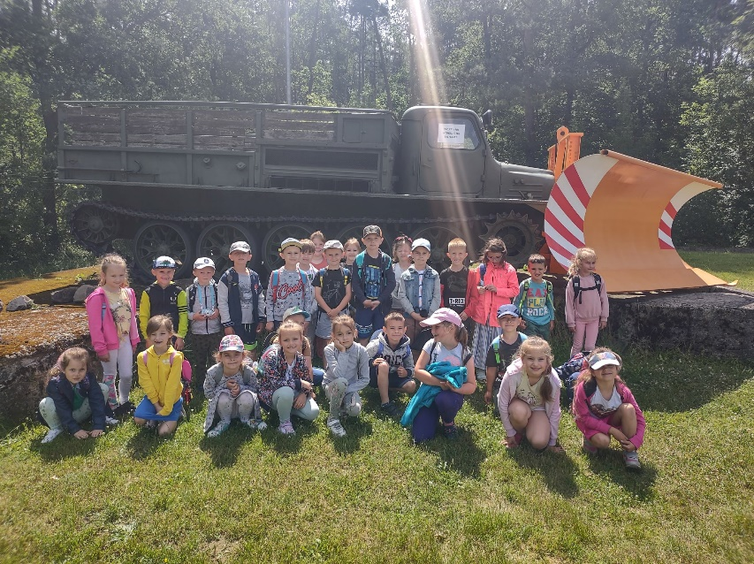
Wycieczka do Muzeum Drogownictwa
w Szczucinie

https://www.facebook.com/Szko%C5%82a-Podstawowa-Borowa-103319884856629/photos/pcb.534195185102428/534194445102502/

XXI Ogólnopolski Tydzień Czytania Dzieciom

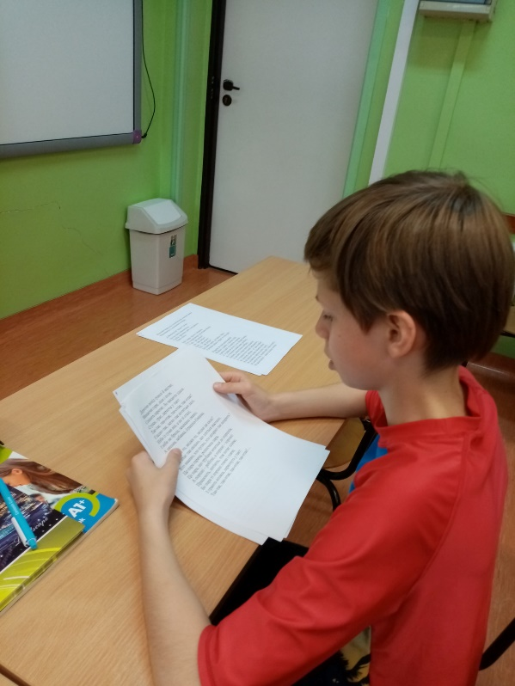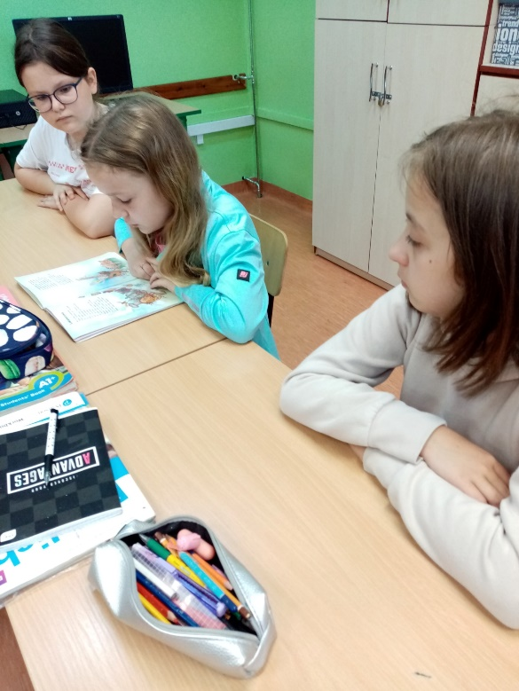
https://spborowa.edupage.org/news/?eqa=d2lkPW5ld3NfTmV3c18xX3AmbmV3c2FyY2hpdmVmPSZvZmZzZXRfbmV3c19OZXdzXzFfcD0w#

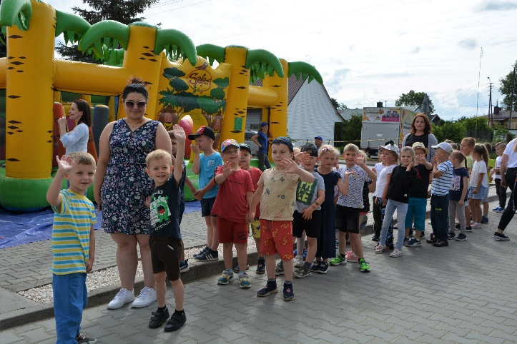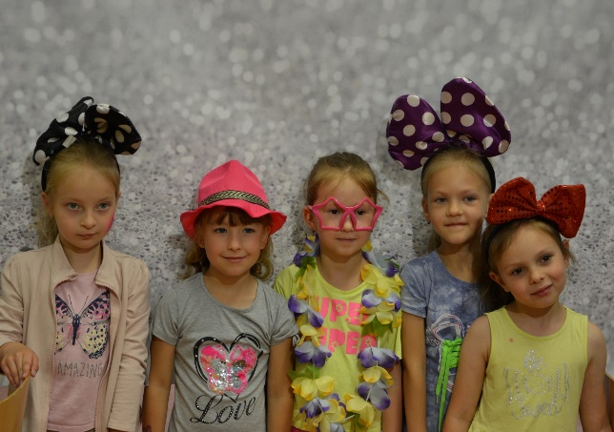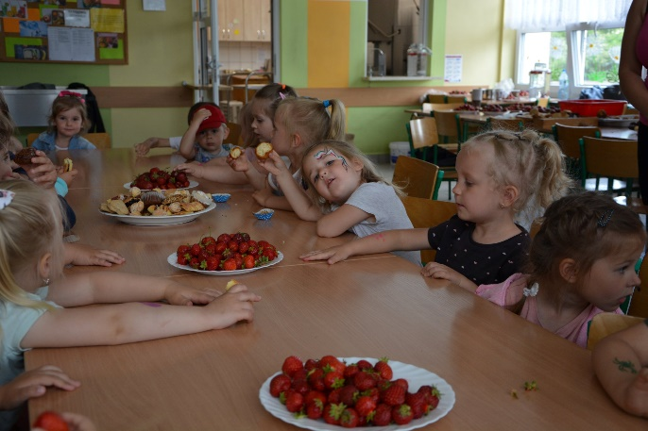
Dzień Dziecka i Sportu Szkolnego
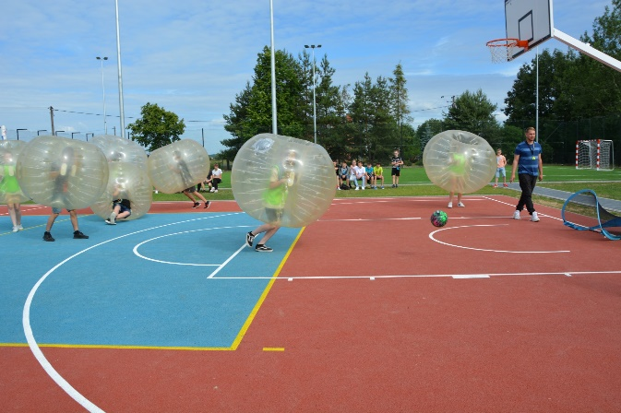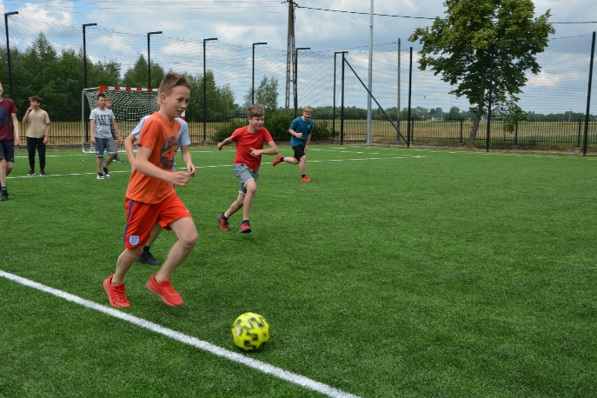

https://spborowa.edupage.org/news/?eqa=d2lkPW5ld3NfTmV3c18xX3AmbmV3c2FyY2hpdmVmPSZvZmZzZXRfbmV3c19OZXdzXzFfcD0w#

Wycieczka do Wrocławia

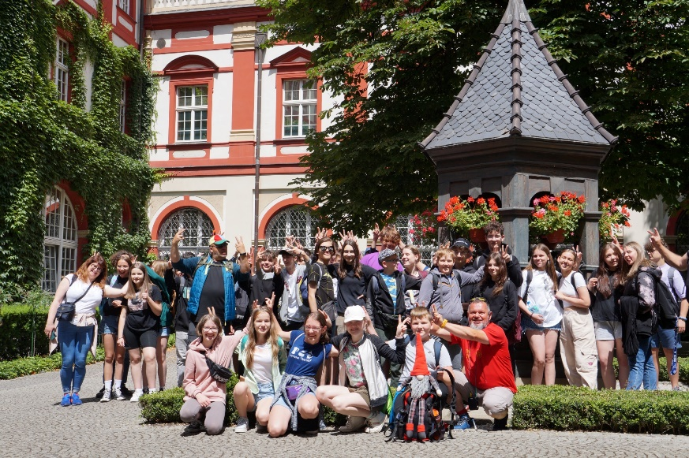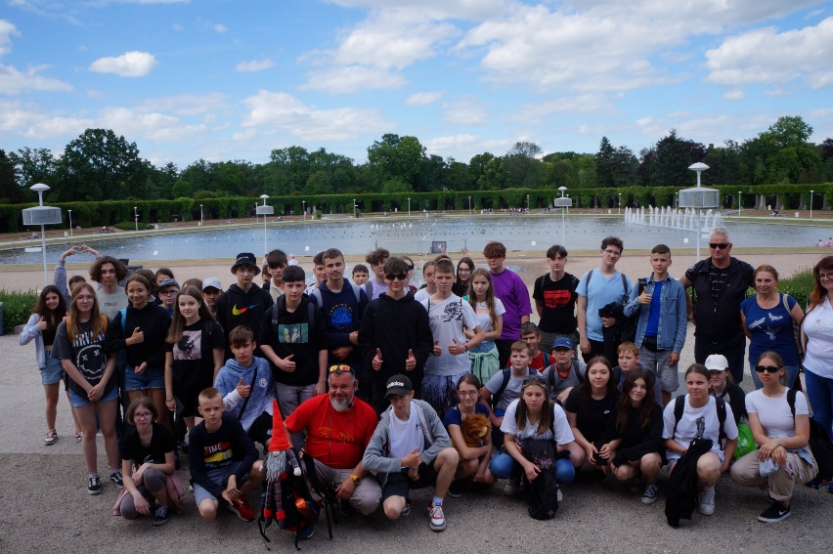

https://spborowa.edupage.org/news/?eqa=d2lkPW5ld3NfTmV3c18xX3AmbmV3c2FyY2hpdmVmPSZvZmZzZXRfbmV3c19OZXdzXzFfcD0w#

Egzamin na kartę rowerową

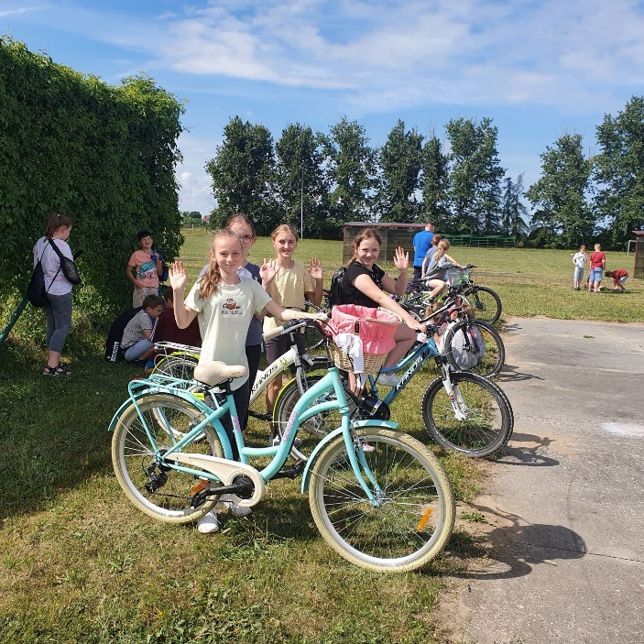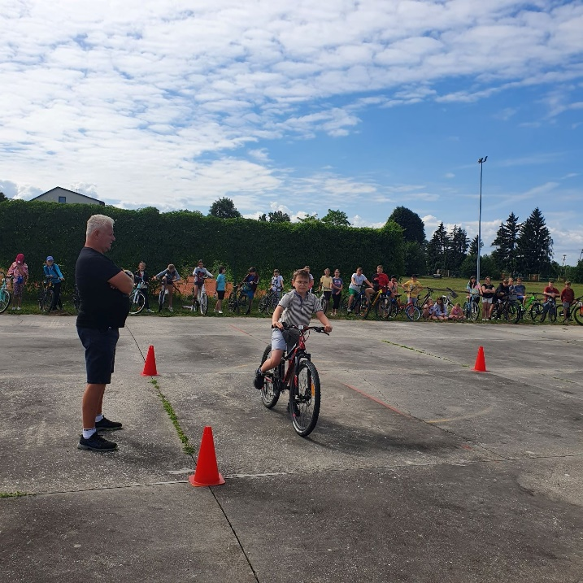

https://spborowa.edupage.org/news/?eqa=d2lkPW5ld3NfTmV3c18xX3AmbmV3c2FyY2hpdmVmPSZvZmZzZXRfbmV3c19OZXdzXzFfcD0w#

Sukces Błażeja

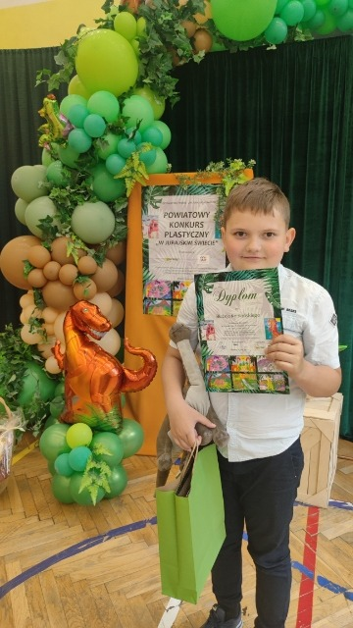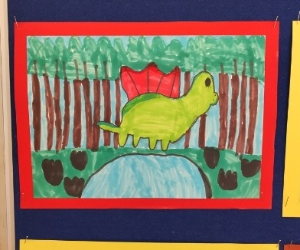

https://spborowa.edupage.org/news/?eqa=d2lkPW5ld3NfTmV3c18xX3AmbmV3c2FyY2hpdmVmPSZvZmZzZXRfbmV3c19OZXdzXzFfcD0w#
Rozstrzygnięcie szkolnego konkursu piosenki ,,Rozśpiewana szkoła”

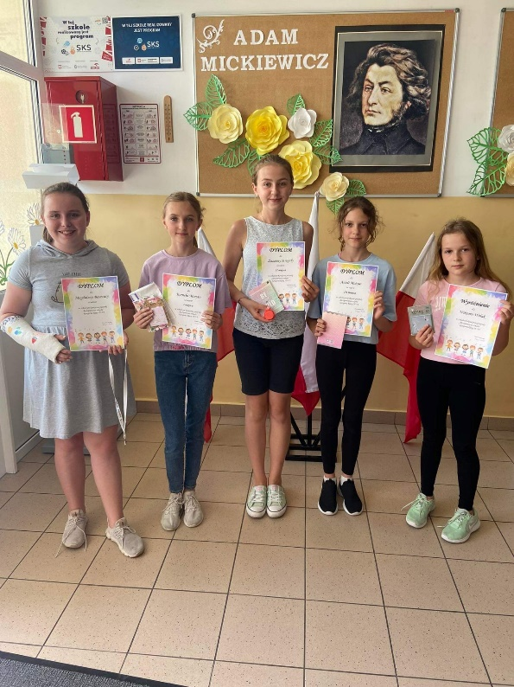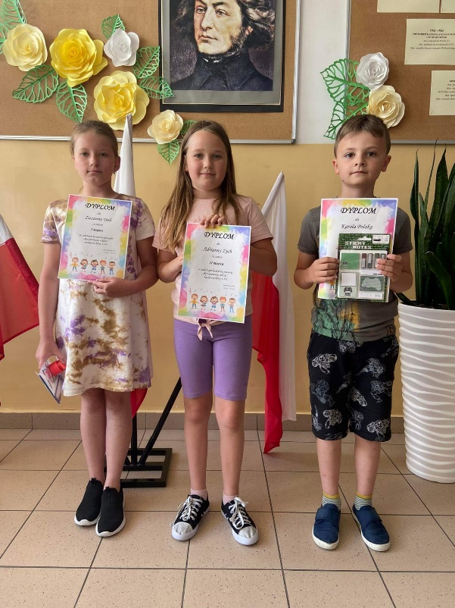

https://spborowa.edupage.org/news/?eqa=d2lkPW5ld3NfTmV3c18xX3AmbmV3c2FyY2hpdmVmPSZvZmZzZXRfbmV3c19OZXdzXzFfcD0w#
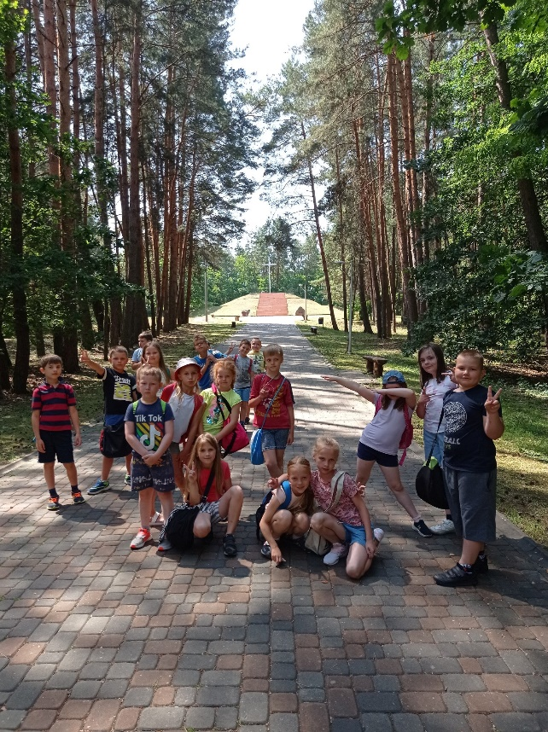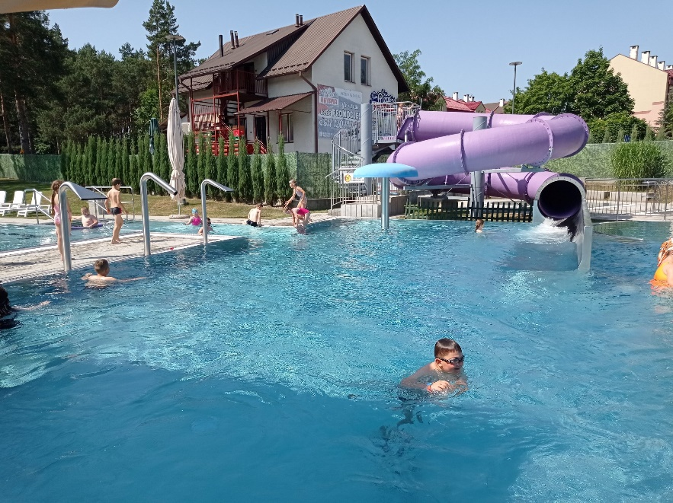
Zakończenie lekcji pływania na basenie II b

https://www.facebook.com/Szko%C5%82a-Podstawowa-Borowa-103319884856629/photos/pcb.538573121331301/538572997997980/
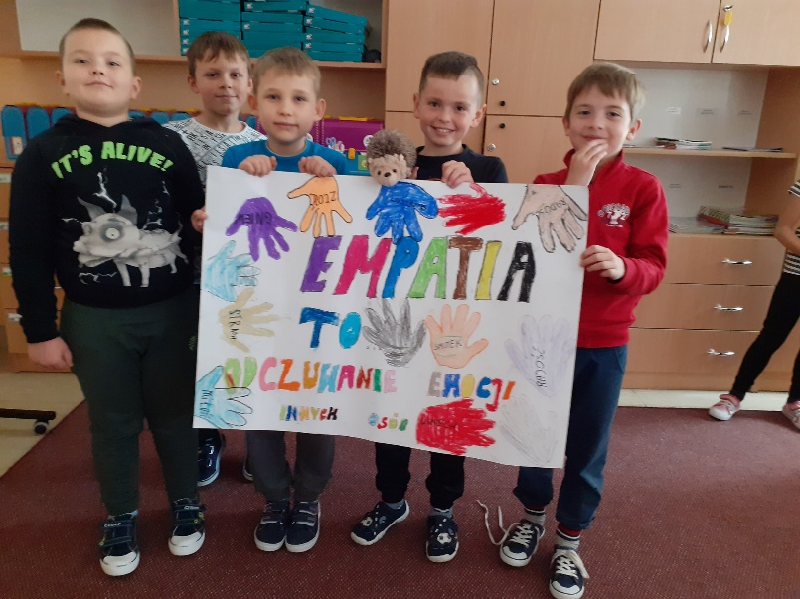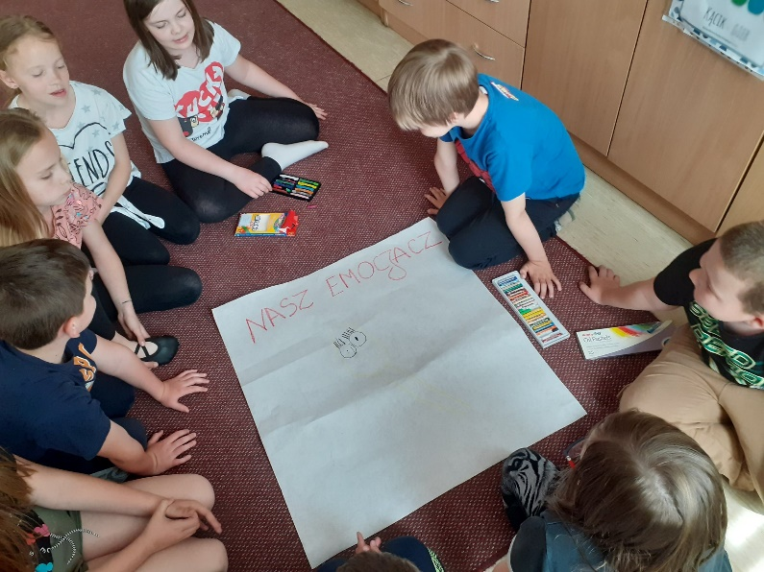
Innowacja pedagogiczna ,,Eko- Emocja” wraz z projektem ,,Emocje”

https://www.facebook.com/Szko%C5%82a-Podstawowa-Borowa-103319884856629/photos/pcb.538574377997842/538574157997864/

Bilety powrotne do biblioteki- skasowane
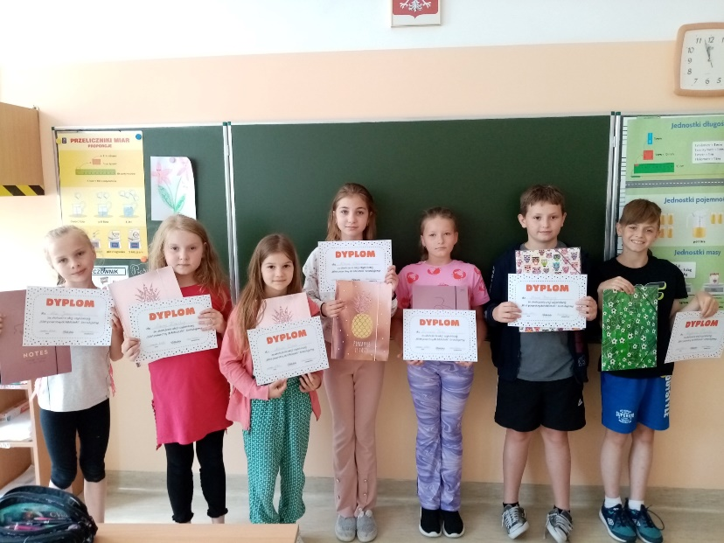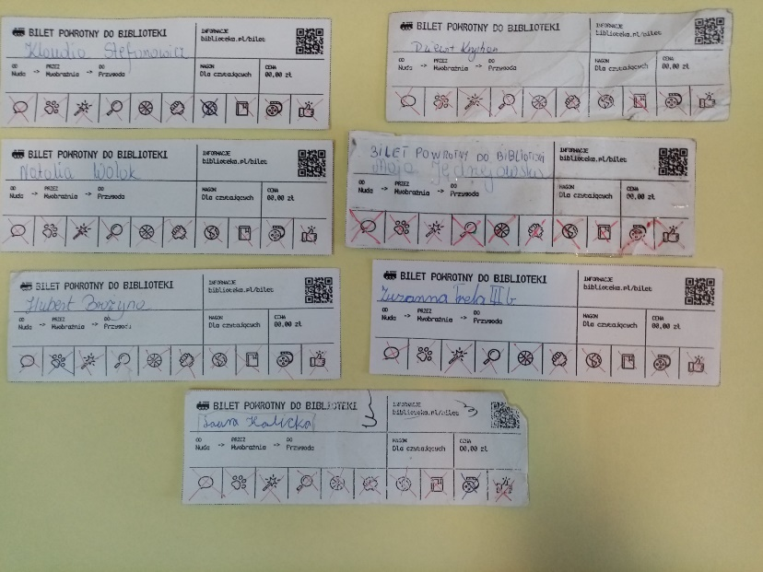

https://spborowa.edupage.org/news/?eqa=d2lkPW5ld3NfTmV3c18xX3AmbmV3c2FyY2hpdmVmPSZvZmZzZXRfbmV3c19OZXdzXzFfcD0w#

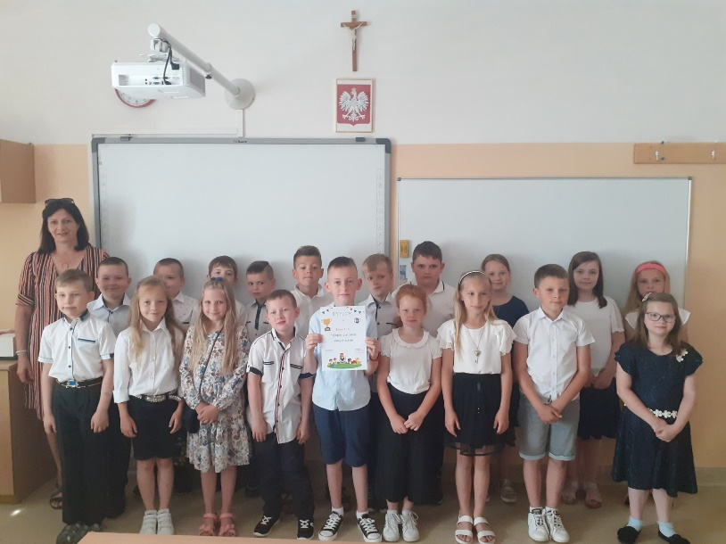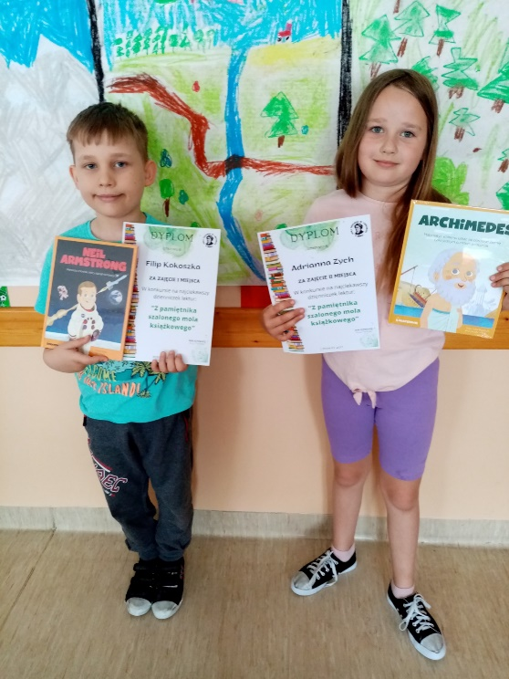
Całoroczne konkursy biblioteczne -rozstrzygnięte

https://spborowa.edupage.org/news/?eqa=d2lkPW5ld3NfTmV3c18xX3AmbmV3c2FyY2hpdmVmPSZvZmZzZXRfbmV3c19OZXdzXzFfcD0w#

Rozstrzygnięcie konkursu plastycznego ,,Kwiaty dla mamy i taty”

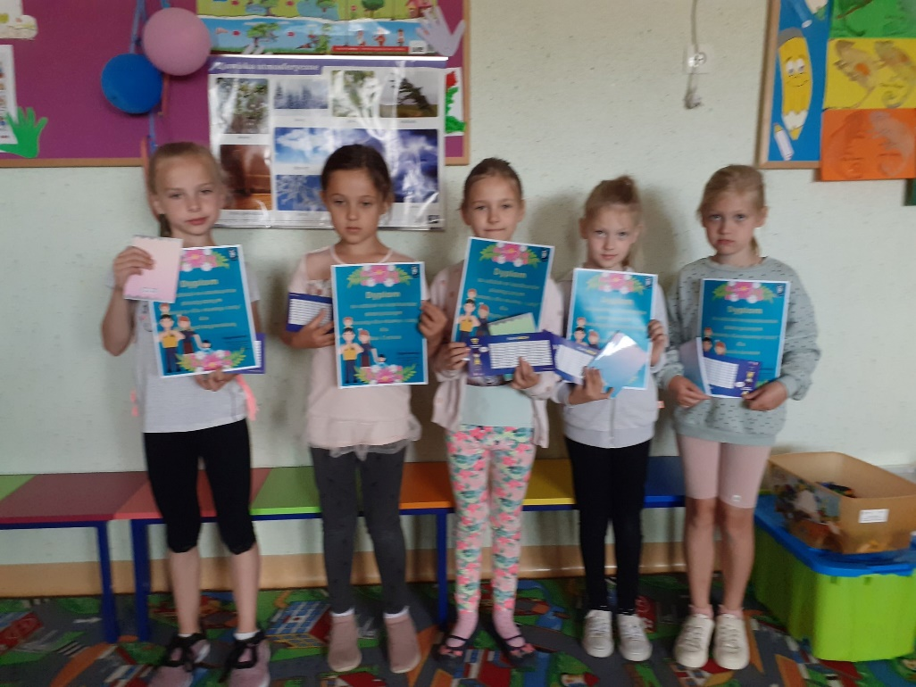

https://www.facebook.com/103319884856629/photos/a.103321321523152/539466911241922/
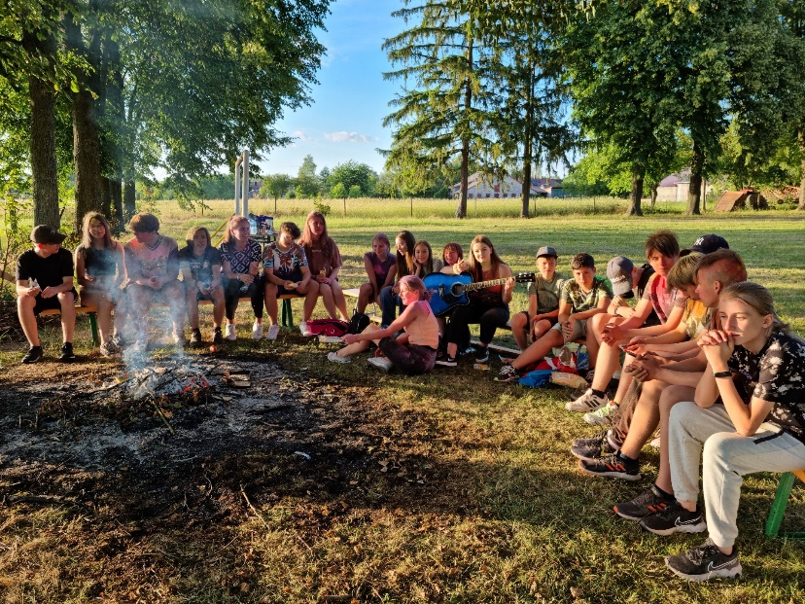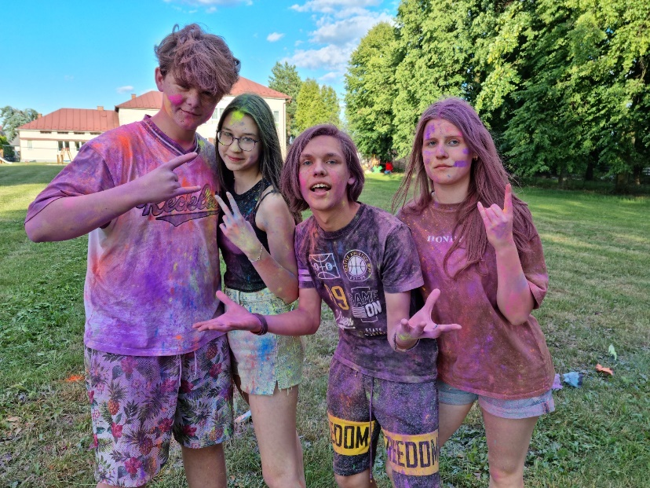
Ognisko Samorządu Uczniowskiego na zakończenie roku szkolnego 2021/2022 połączone z festiwalem kolorowych pyłków Holi

https://spborowa.edupage.org/news/?eqa=d2lkPW5ld3NfTmV3c18xX3AmbmV3c2FyY2hpdmVmPSZvZmZzZXRfbmV3c19OZXdzXzFfcD0w#

Projekt trójstronny w języku niemieckim ,,Bez granic- wirtualny kurs gotowania pod patronatem Goethe- Institut

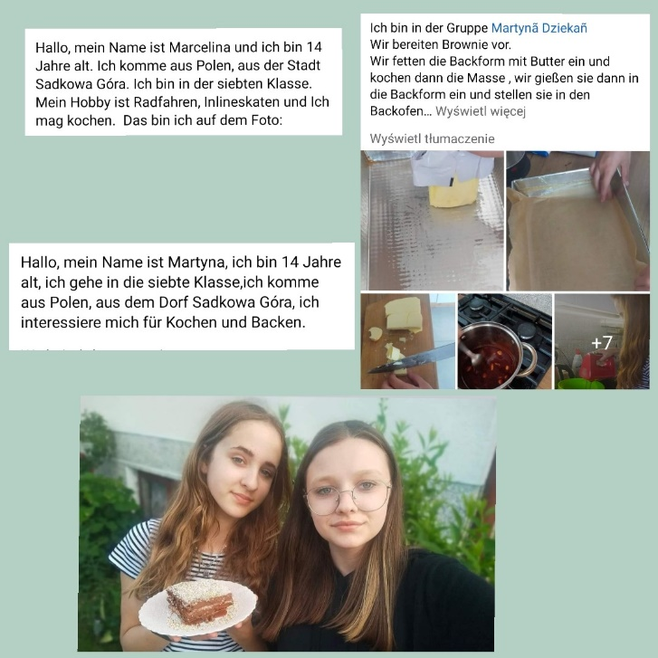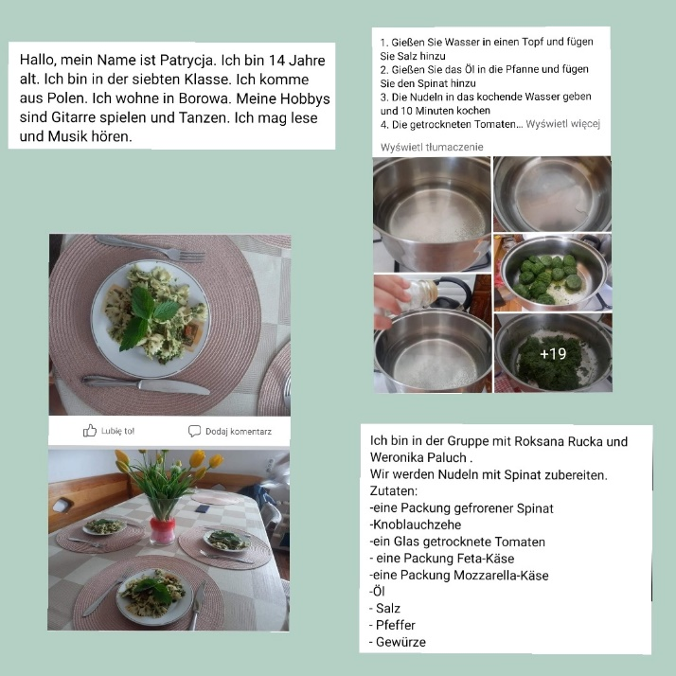

https://spborowa.edupage.org/news/?eqa=d2lkPW5ld3NfTmV3c18xX3AmbmV3c2FyY2hpdmVmPSZvZmZzZXRfbmV3c19OZXdzXzFfcD0w#

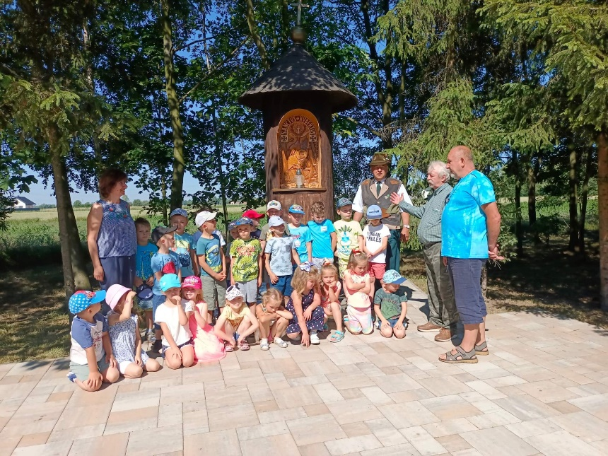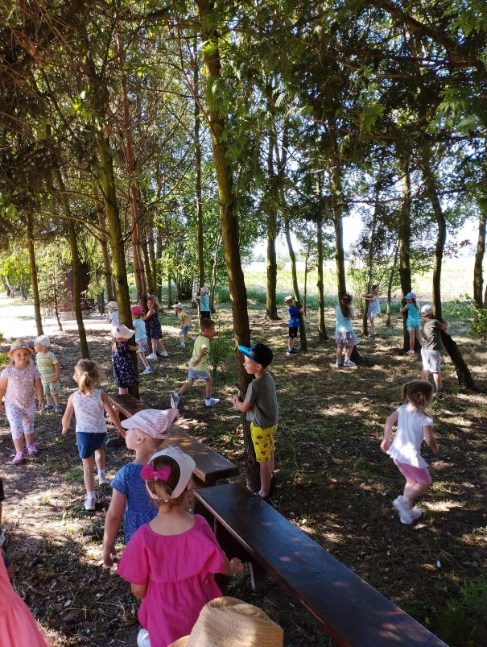

Wycieczka przedszkolaków do Koła Łowieckiego Bażant
https://spborowa.edupage.org/news/?eqa=d2lkPW5ld3NfTmV3c18xX3AmbmV3c2FyY2hpdmVmPSZvZmZzZXRfbmV3c19OZXdzXzFfcD0w#

Ostatni dzwonek

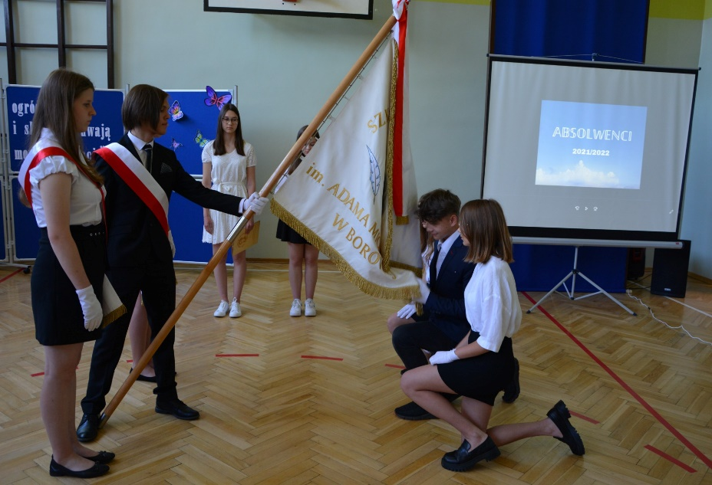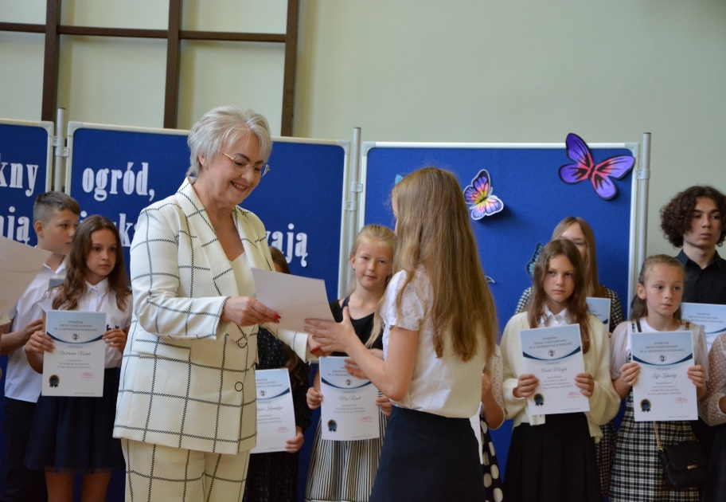

https://spborowa.edupage.org/news/?eqa=d2lkPW5ld3NfTmV3c18xX3AmbmV3c2FyY2hpdmVmPSZvZmZzZXRfbmV3c19OZXdzXzFfcD0w#

